Cal Poly FSAE Electric Car Electronics 2018-19

Vehicle Control Unit

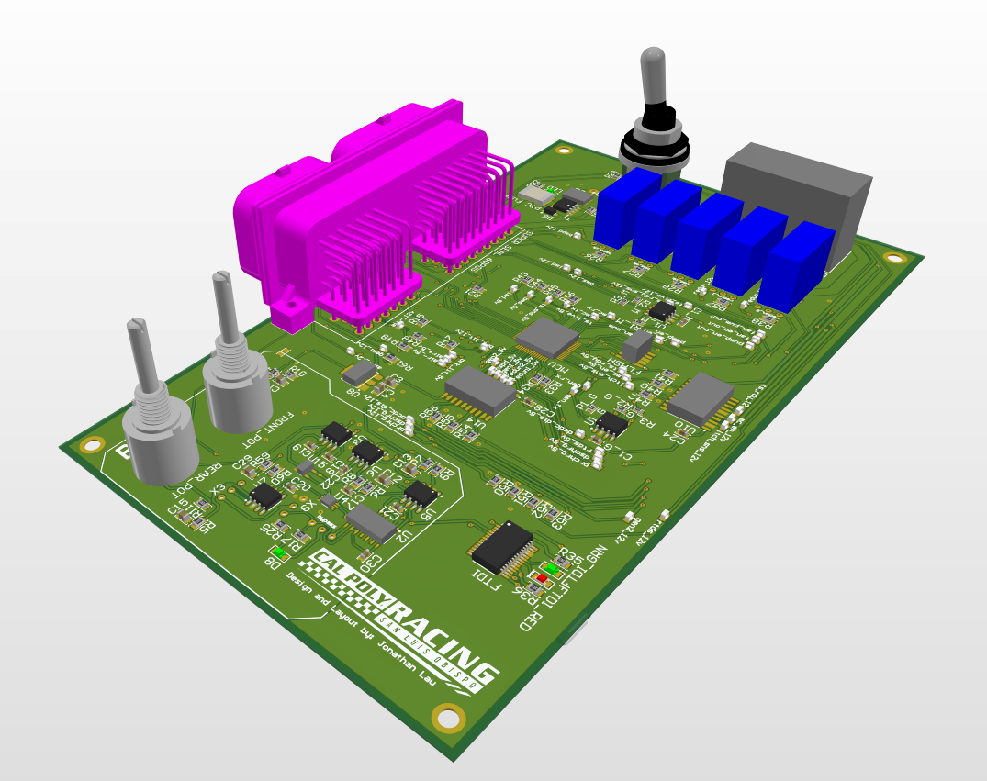

Design and layout by Jonathan Lau

Overview

The vehicle control unit (VCU), shown in Figure 1-1 and 1-2, is part of the overall electrical control unit of Cal Poly Racing’s 2019 electric car. The purpose of this unit is to control several functions of the car such as precharge, discharge, fans, cooling pump, etc. via controller area network (CAN) and GPIO outputs from the microcontroller on-board.

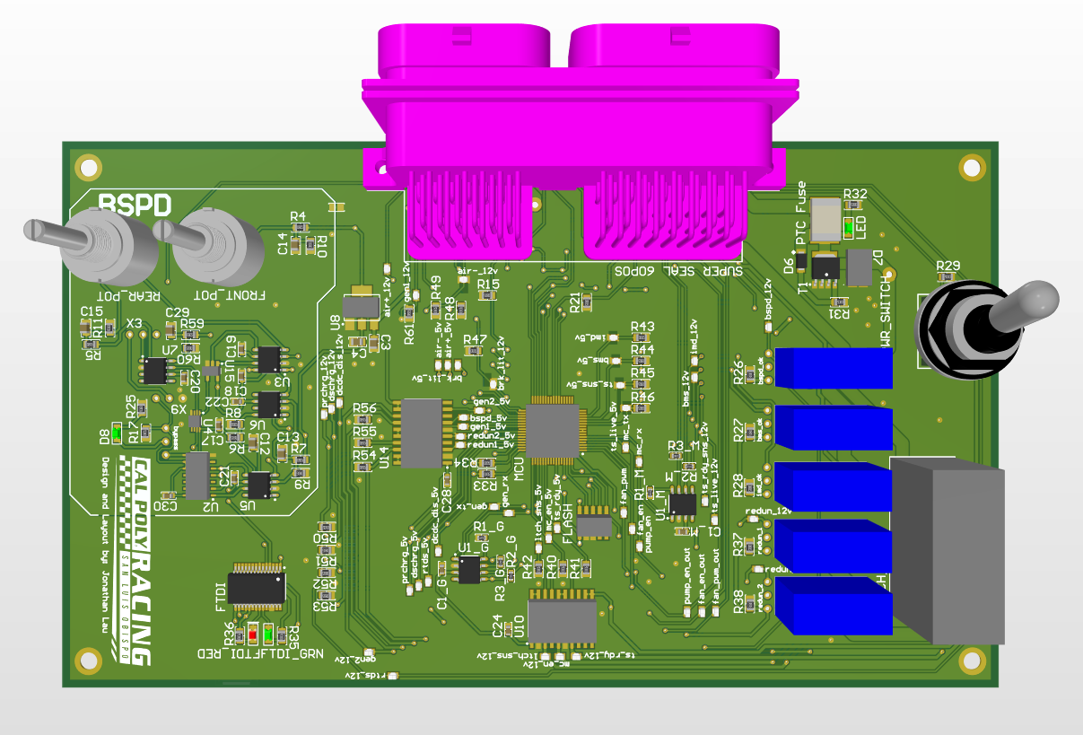

Figure 1-1. VCU top view

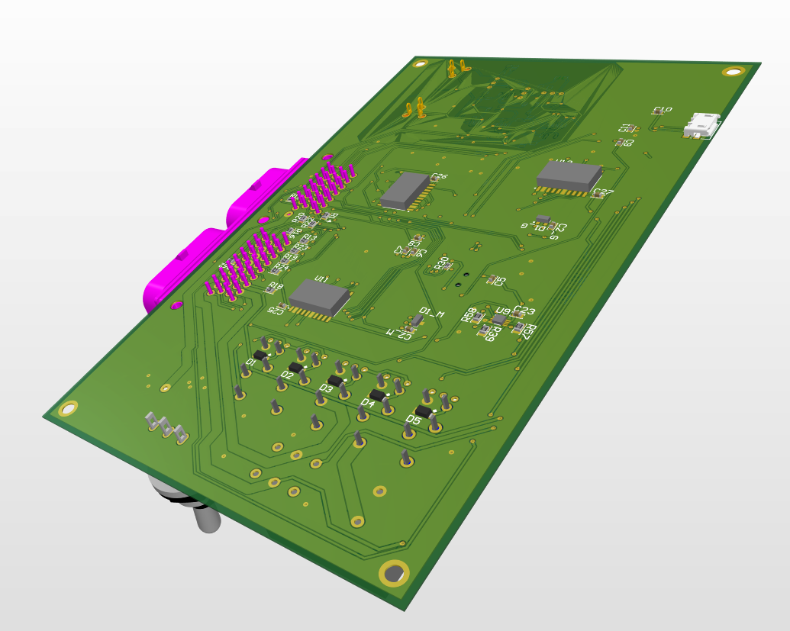

Figure 1-2. VCU bottom view

Aside from system control, the VCU also handles safety precautions through non-digital subunits on the board, such as the brake system plausibility device (BSPD) and the tractive-system-ready relays. These subunits shut down the car if certain failures occur as the car is in motion.

Top-level design of the VCU is shown in Figure 1-3 below. This document seeks to discuss the functions of each subunit within the VCU, separated by block diagrams within the top-level schematic.

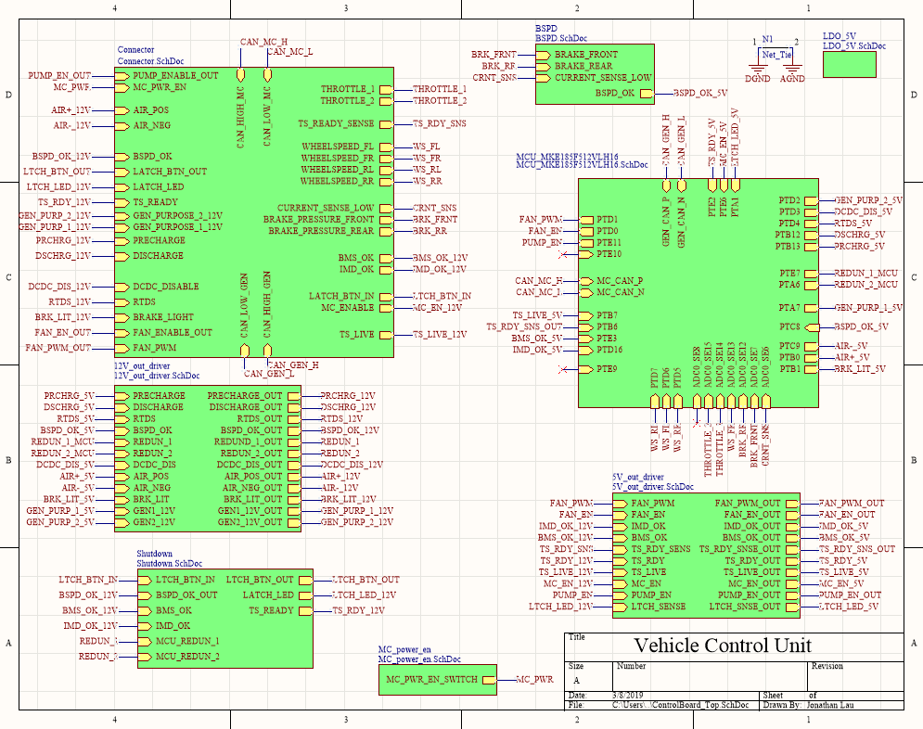

Figure 1-3. VCU signal bussing at top level

In summary, this year’s VCU is composed of the following subunits:

* Microcontroller (MCU) for general software-based control of the car
* Brake system plausibility device (BSPD)
* Tractive-system ready relays for driver safety
* 5V output and 12V output drivers for signal conversion

Microcontroller unit (MCU)

In the past, Cal Poly Racing’s electric car was controlled by an SBRIO, with a daughter card for interfacing. Despite the usefulness of the SBRIO, modifications of the car’s electronics in the future would be difficult due to the entry barrier of editing software through LabVIEW. This year, the electronics are microcontroller based, allowing for greater flexibility for modifications in the future. Figure 2-1 shows the schematic for the MCU, imported from Cal Poly Racing’s universal design library and edited as necessary for functions specific to the VCU.

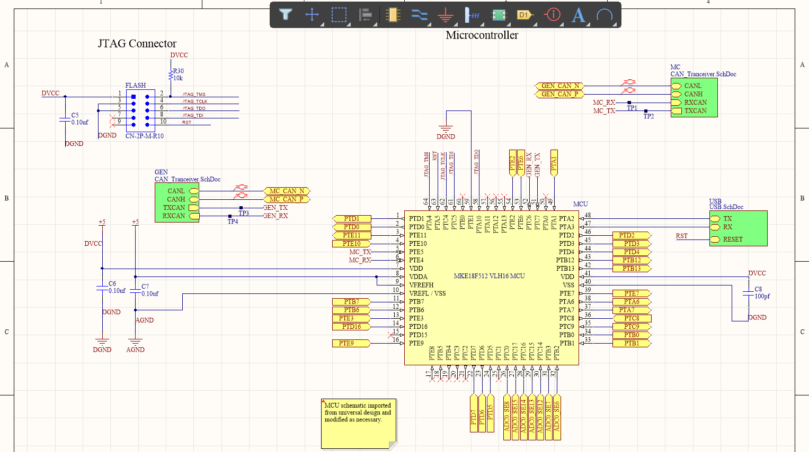

Figure 2-1. Schematic of MCU

As seen in Figure 6-1, the MCU used in this year’s VCU includes on-chip ADC pins, cutting out the need for external Analog-to-Digital circuitry that might otherwise occupy precious space on the board. However, this also limits the freedom of MCU placement on the PCB, since greater care must be taken now to ensure digital signals do not interfere with analog signals by virtue of bad trace routing. As seen in Figure 2-2, analog signals routed to the MCU do not cross over digital signals on the board.

Due to the nature of how the motor controller (MC) talks over the CAN line in short bursts, a separate CAN line is dedicated to it this year, to prevent messy communication in the general CAN line.

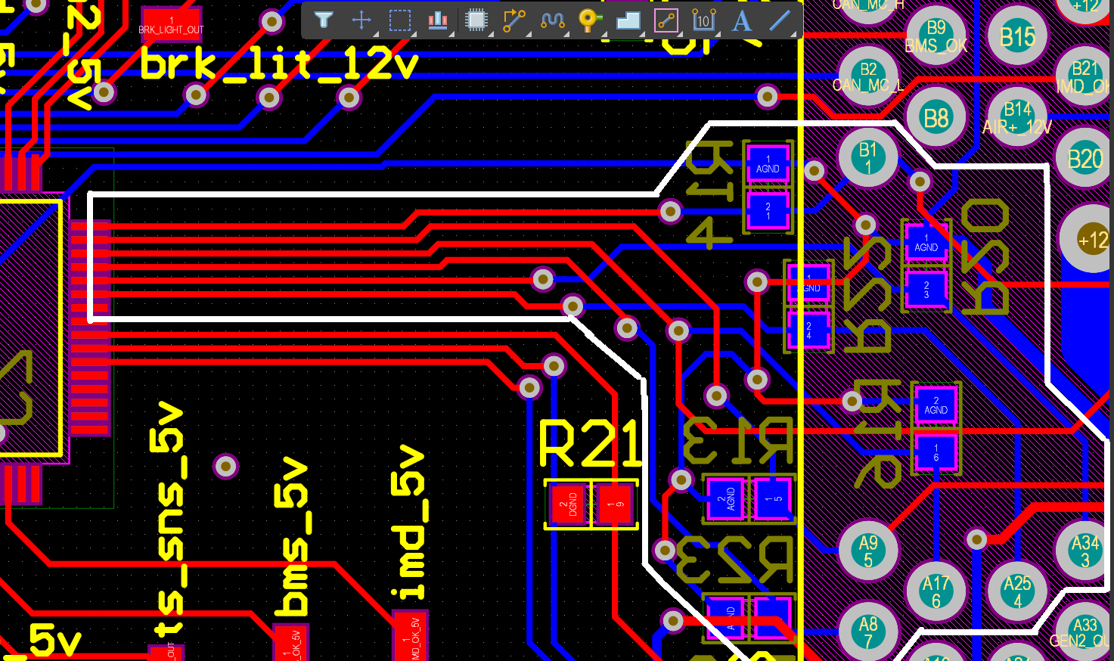

Figure 2-2. Analog signal routing to MCU

Table 2. Key components used in MCU

|  |  |  |
| --- | --- | --- |
| Component | Part Number | Datasheet |
| 64-pin microcontroller | MKE18F512VLH16 | https://www.nxp.com/docs/en/data-sheet/KE1xFP100M168SF0.pdf |
| High-speed CAN transceiver | MCP2561/2 | http://ww1.microchip.com/downloads/en/DeviceDoc/20005167C.pdf |
| USB-UART IC | FT232RL | https://www.ftdichip.com/Support/Documents/DataSheets/ICs/DS_FT232R.pdf |
| ESD-protection diodes | NUP1105L-D | https://www.onsemi.com/pub/Collateral/NUP1105L-D.PDF |

Brake System Plausibility Device (BSPD)

The purpose of this unit within the VCU is to determine, through non-programmable means, if the car is being driven in an unsafe manner, where the driver applies throttle while braking hard, simultaneously. If the above situation occurs, an OK signal sent from the BSPD to the shutdown relays will be disrupted, opening a path in the TS-ready signal line and shutting down the car. Schematic of the BSPD design is shown in Figure 3-1 below.

Input signals:

* Front brake pressure
* Rear brake pressure
* Battery-pack output current sense

Output signal:

* BSPD_OK

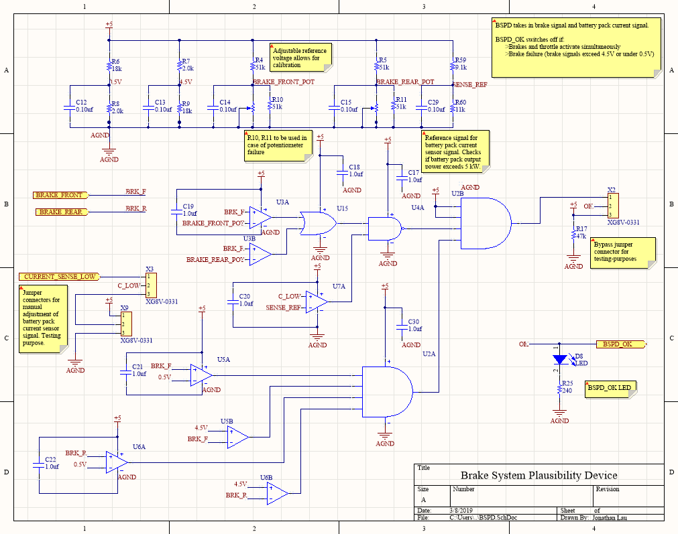

Figure 3-1. Schematic design of BSPD

Layout of the BSPD is shown in Figure 3-2. An analog ground plane is dedicated specifically for the BSPD, allowing for cleaner input signals.

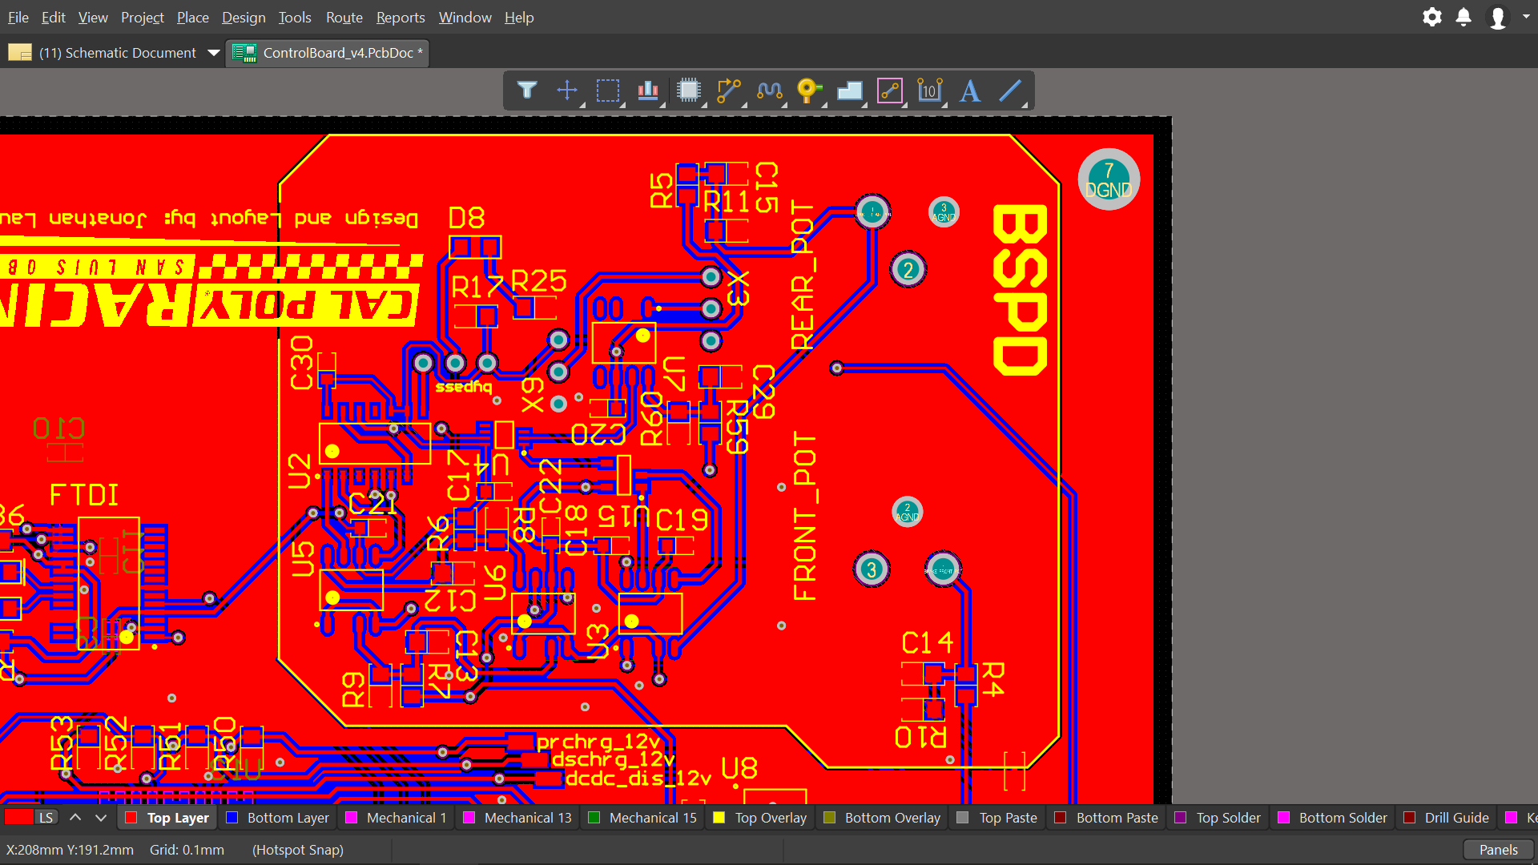

Figure 3-2. BSPD Layout

Table 3. Key Components used in BSPD

|  |  |  |
| --- | --- | --- |
| **Component** | **Part number** | **Datasheet** |
| Dual comparators | LT1018 | https://www.analog.com/media/en/technical-documentation/data-sheets/10178ff.pdf |
| 1-channel 2-input OR gate | SN74LVC1G32 | http://www.ti.com/lit/ds/sces219v/sces219v.pdf |
| 2-channel 4-input AND gate | 74HC21 | https://assets.nexperia.com/documents/data-sheet/74HC21.pdf |
| 2-channel 2-input NAND gate | SN74LVC2G132DCUR | http://www.ti.com/lit/ds/symlink/sn74lvc2g132.pdf |
| Green LED | CMD17-21 | https://vcclite.com/wp-content/uploads/wpallimport/files/files/CMD1721Seriesver3.pdf |

Tractive-System Ready Relays (Shutdown Relays)

The shutdown relays within the VCU drive a TS-ready signal that goes to the rest of the car. If the TS-ready signal is disrupted by a relay opening, the car shuts down until it is restarted externally by someone other than the driver. Schematic design is shown in Figure 4-1.

Input signals:

* BSPD_OK
* BMS_OK
* IMD_OK
* MCU_REDUNDANCY_1
* MCU_REDUNDANCY_2
* LATCH_BUTTON_IN

Output signals:

* TS_READY
* LATCH_BUTTON_OUT

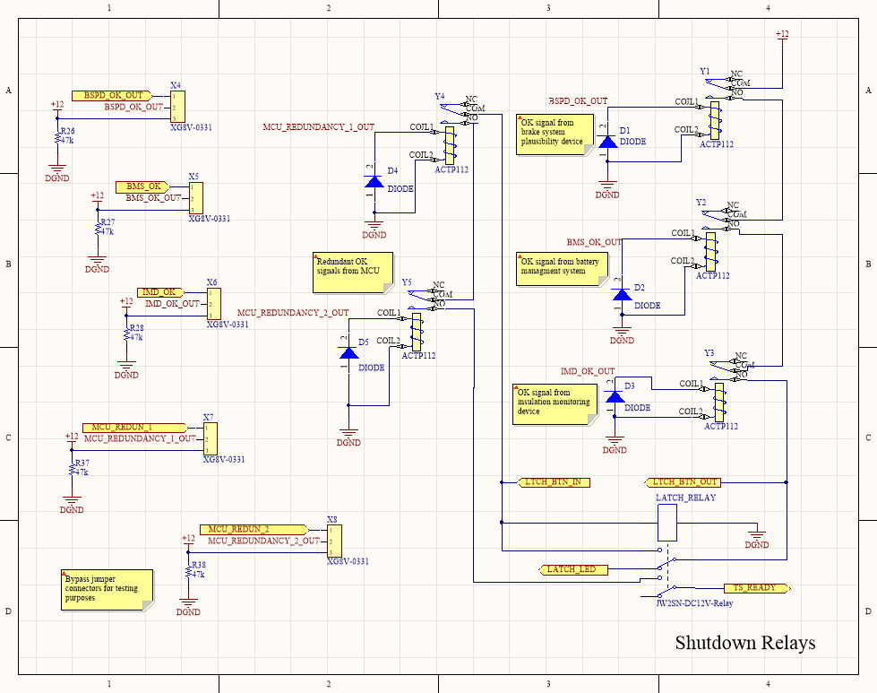

Figure 4-1. Schematic design of shutdown relays

During normal operation, where all OK signals are on and the relays are closed, The TS-ready signal gets sent to other units in the car when a latch button is pressed, closing the latch relay and keeping it latched until one or more relays are opened, disrupting the TS-ready signal line and unlatching latch relay. The addition of bypass jumper connectors this year facilitates ease of testing. They send current to the relay coils and closes the relays, simulating OK signals.

Inputs BMS_OK and IMD_OK comes from the battery management system (BMS) and the insulation monitoring device (IMD) from elsewhere on the car. BSPD_OK comes from the BSPD on-board. The MCU also checks for safe operation of the E-car through software and outputs an OK signal to the relays.

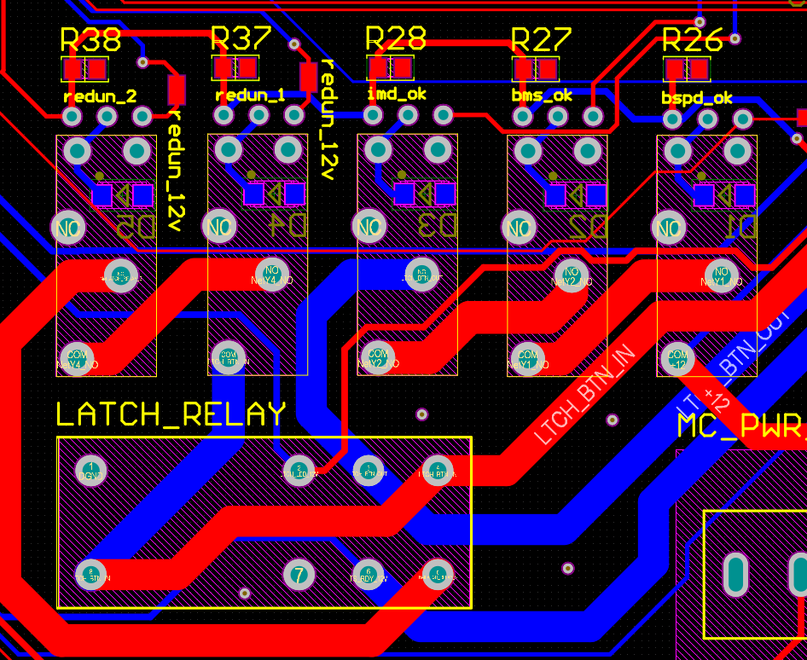

Figure 4-2. Layout of shutdown relays

Layout of shutdown relays is shown in Figure 4-2. The size of the signal trace is decided based on the large amount of current passing through. The accumulator insulation relays (AIRs) in another part of the car draws an instantaneous current that spikes to 3A through the TS-ready line, so the trace must be thick enough to handle it.

Table 4. Key components used in TS-ready relays

|  |  |  |
| --- | --- | --- |
| Component | Part number | Datasheet |
| CT power relays | ACTP112 | https://www.panasonic-electric-works.com/pew/cz/downloads/ds_61205_en_ct_power.pdf |
| Latch relay | JW2SN-DC12 | https://www.jameco.com/Jameco/Products/ProdDS/843235.pdf |

5V-to-12V Signal Conversion Drivers

Several digital signals in the VCU routes to the rest of the car as 12V signals, controlled by the microcontroller. Since the microcontroller outputs them as 5V, they need to be stepped up to 12V before being sent out to other ECU units in the car. Below, schematic design of the 12V drivers is shown in Figure 5-1.

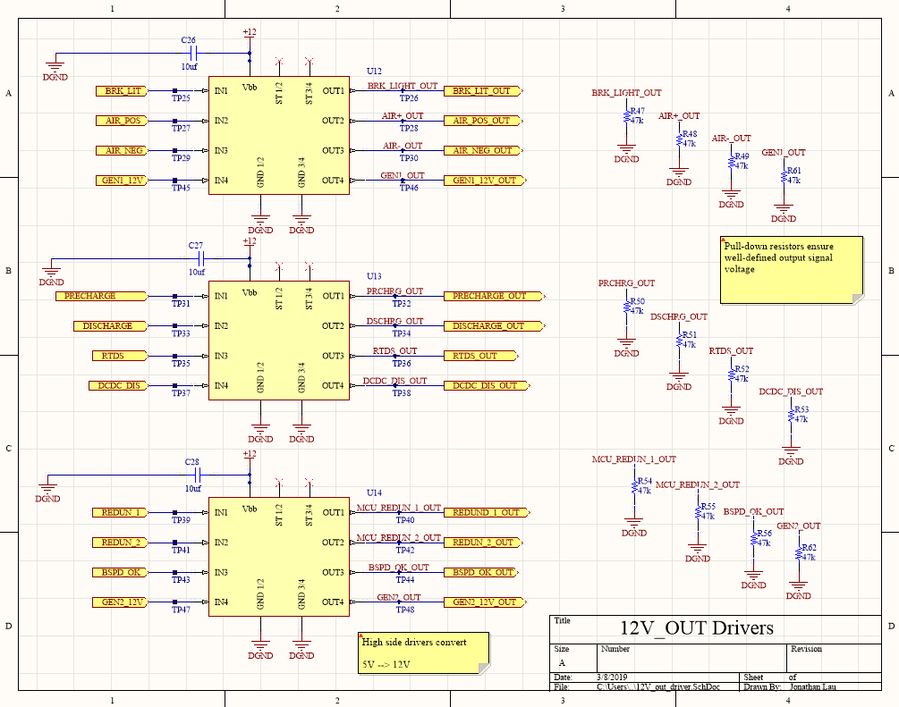

Figure 5-1. Schematic design of 12V output drivers

Table 5. Key components used in 12V output drivers

|  |  |  |
| --- | --- | --- |
| **Component** | **Part number** | **Datasheet** |
| High side drivers | BTS716GXUMA1 | https://www.digikey.com/product-detail/en/infineon-technologies/BTS716GXUMA1/BTS716GXUMA1CT-ND/520067 |

12V-to-5V Signal Conversion Drivers

The purpose of these high-side drivers is mostly to convert 12V input signals to 5V signals that the microcontroller can handle and processes. This subunit also drives fan PWM, fan enable, and cooling pump enable signals through inverters.

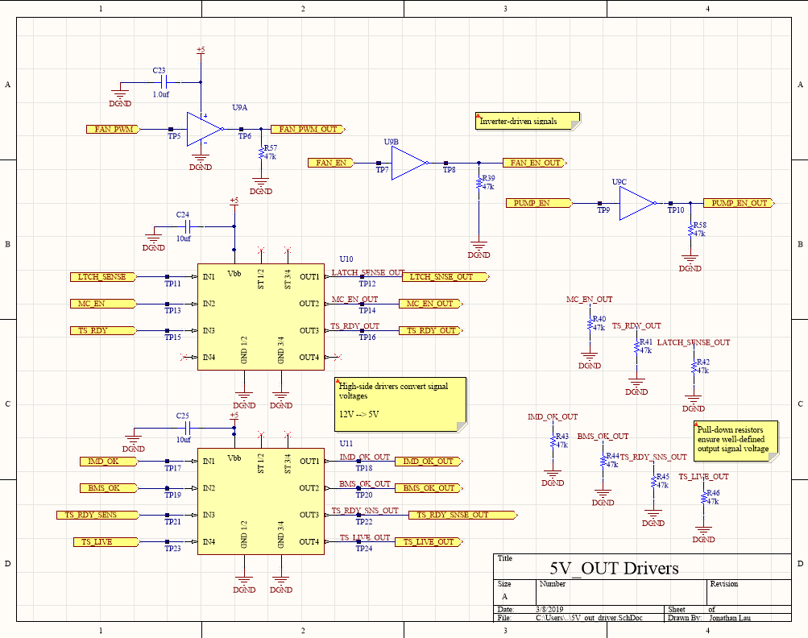

Figure 6-1. Schematic design of 5V output drivers

Table 6. Key components used in 5V output drivers

|  |  |  |
| --- | --- | --- |
| **Component** | **Part number** | **Datasheet** |
| High side drivers | BTS716GXUMA1 | https://www.digikey.com/product-detail/en/infineon-technologies/BTS716GXUMA1/BTS716GXUMA1CT-ND/520067 |
| Inverters | SN74LVC3G14DCUR | https://www.digikey.com/product-detail/en/texas-instruments/SN74LVC3G14DCUR/296-13006-1-ND/475831 |